A Symbiotic System Approach for the Development of Canadian Oil Sands

And The Potential For Positive Impact On The Decision To Build The Keystone Pipeline

Prof. Alexander H. Slocum (slocum@mit.edu)

Massachusetts Institute of Technology

David James Taylor (dtaylor@mit.edu)

Massachusetts Institute of Technology

Kevin Patrick Simon (kevinpsi@mit.edu)

Massachusetts Institute of Technology

Santiago Paiva (santiago.paiva@cs.mcgill.ca)

McGill University

**Abstract**

We propose a symbiotic system approach for the development of Canadian Oil Sands. We show, for example, if 20% of Canadian Oil Sands income were to be invested in renewable-energy machines as part of reclamation efforts for the land that is mined for the oil sands, then in 30-40 years as much CO2 will have been kept from the air from burning coal to make electricity as was released into the air from mining the oil sands and consuming the oil. Furthermore, in a period of excess electricity power generation, the power can be used to clean contaminated water of Poly-Aromatic Hydrocarbons (PAH) and hydrocrack PAH into useful compounds.

Contents

1 Introduction 3

1.1 Motivation 3

1.2 Problem Domain 3

2 Alberta's Oil Sands Analysis 6

2.1 Mining and Production of Oil Sands 6

2.2 The Keystone XL Pipeline 6

2.3 Company ROI Analysis 7

3 Improved EROI for Companies by Investing in Renewable Energy 8

3.1 EROI from Investing in Wind Energy 8

3.2 CO2 Saved From Investing in Solar Energy 11

3.3 CO2 offset Calculation 14

4 An Alternative to a Carbon Tax 15

5 Market Expansion and Supply Cost Reduction 15

5.1 Selling Electricity Back to the Grid 16

5.2 Cleaning Water Contamination 16

6 Conclusion 17

References 18

# 1 Introduction

## 1.1 Motivation

Beneath the boreal forest in Northern Canada lies the world's 2nd largest oil reserve, known as the oil sands. The oil sands are a mixture of sand and a heavy crude oil called bitumen. Natural bitumen is reported in 598 deposits in 23 countries, with the largest deposits in Canada, Kazakhstan, and Russia. Bitumen reserves are estimated at 249.67 billion barrels out of which 178 billion barrels (70.8%) are in Canada (Alberta) [1].

The Northern Alberta region contains 98% of the Canadian oil sands and they are divided into three regions:

* The Athabasca-Wabiskaw deposits region
* The Cold Lake deposits regions
* The Peace River deposits region

Together, they cover 140,200 square kilometers [2]. It is also estimated by the Government of Canada that these regions hold proven reserves up to 1.75 trillion barrels of bitumen in place [9]. In addition, 173 billon barrels (10%) estimated to be recoverable at current prices using current technology.

This amounts to 97% of Canadian Oil reserves and 75% of total North American petroleum reserves. It is further estimated that 90% of the Alberta oil sands are too far below the surface to use open-pit mining. The Canadian government has decided the creation of the Keystone XL pipeline which would allow mining companies to get further access to the mineral.

The plans for this pipeline have been thwarted because of environmental concerns In this paper, we demonstrate how better alternatives such as investment in Wind Turbines and Photovoltaic (PV) Solar Cells not only will result in a significant reduction of CO2 emissions, but prove to be a solid green option for the future of Alberta and the country.

## 1.2 Problem Domain

The Province of Alberta is currently operating on poor energy return per area invested. Alberta's Oil Sands are being mined over a vast area which will destroy large swaths of forests releasing even more carbon into the atmosphere. Just mining the oil and consuming it could have a huge impact on climate change. Poisson *et al* [17] recently demonstrated that since the 1990s, the total energy used (invested) in the Canadian oil and gas sector increased approximately 63%, while energy production (return) increased only 18% resulting in a decreased total energy return on investment (EROI) from 16:1 to 11:1. In the spirit of increasing the EROI from this vast resource, we present a possible better EROI for the area and the country.

In addition to improving EROI, we also provide an alternative to a carbon tax which benefits both parties, both the government and the companies mining oil sands. This alternative allows companies to reinvest in their future while positioning themselves towards being completely carbon neutral.

Finally, we also demonstrate that companies can benefit from this solution by creating expansion markets which, in turn, improves their ROI. For instance, companies could use the excess power from the wind turbines to sell it back to the grid, clean the contaminated water that got polluted, and sell pesticides or plastics by cranking the compounds found in the water.

**Hypothesis:**

*The effect of oil sands utilization on climate change does not have to be negative IF as part of land reclamation of the mined oil sands area, developers of the oil sands resource were required to plan and invest for when the oil sands are depleted. This scenario could include for every square kilometer of land to be reclaimed, a 5 MW wind turbine is installed. The power from the turbine can be used for oil sands production and also sold to the grid.*

Figure 1 below shows an example cumulative effect on CO2 emissions over the years of this land reclamation plan, with 50% of the total oil sands land area being reclaimed with wind turbine installations with a policy of $0.05/kWh reinvestment in purchasing more wind turbines. Similar results are obtained with 15% of the area reclaimed using arrays of PV cells and similar reinvestment policy in purchasing more solar cells.

This requires oil sands developers to invest a portion of sales, $20/bbl for the scenario here, into renewable energy production. This investment represents an alternative a carbon tax because companies are investing in their own future. In addition, it benefits the oil sands companies directly and immediately because they can use the electric power for production of the oil sands instead of having to build more transmission lines to bring power in for which they then have to pay to use. Furthermore, once the number of turbines increases to a point, they can start sending power out on the same power lines they initially had installed to bring power in (are in the process of installing) to develop the oil sands.

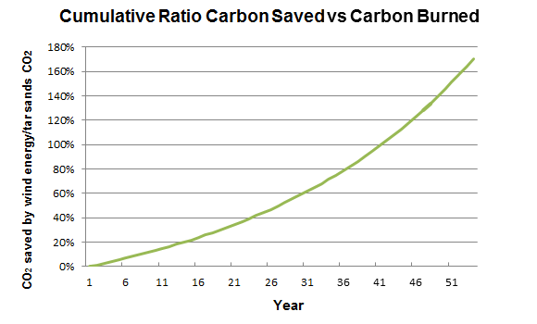

**Figure 1.** Amount of CO2 offset by $20/bbl investment in wind turbines based on $4/Watt installed, with a policy of $0.05/kWh for purchasing more wind turbines. See supplemental materials for spreadsheet to enter different values

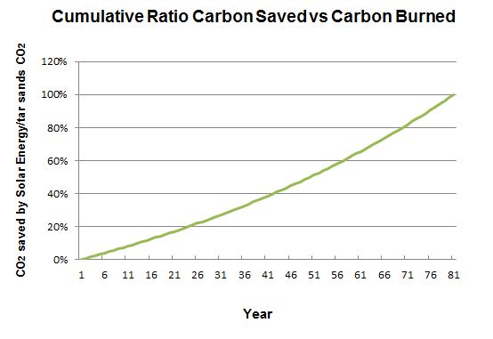

**Figure 2.** Amount of CO2 offset by $20/bbl investment in PV Solar Cells based on $4/Watt installed, with a policy of $0.05/kWh reinvestment for purchasing more solar cells, with up to a maximum of 15% efficiency, covering 30% of the land from a 15% of all total land. See supplemental materials for spreadsheet to enter different values

# 2 Alberta's Oil Sands Analysis

## 2.1 Mining and Production of Oil Sands

Per day, oil sands operation release as much CO2 as all the cars in Canada

[8]. According to a report released in 2011 [3], production of oil sands released an estimated of 47.1 million metric tonnes of CO2 into the air. Considering that in 2011, 1.8 million barrels a day were produced, we obtain the following chart:

**Table 1: CO2 from Oil Sands production and oil use**

|  |  |
| --- | --- |
| **Production** | **Use** |
| Oil produced (million barrels per year) | 693.5 |
| CO2 to produce the oil (megatonnes/year) | 50 |
| CO2 from oil use (megatonnes/year) | 298.2 |
| **Total CO2 from Oil sands (megatonnes/year)** | **348** |

The recent announcement of the Keystone XL pipeline would allow the oil sand oil industry to propel mining and production to a whole new level. There is a better alternative.

## 2.2 The Keystone XL Pipeline

As mentioned, the pipeline is a major milestone in the next phase of extracting oil sands under Canada's Boreal Forest to reach higher prices of overseas markets.

Projected Impact of Keystone XL by U.S Department of State in the Final Environmental Impact Statement (FEIS) [4]:

* Projected 830,000 barrels/day flow
* Add between 147 to 168 million metric tons of greenhouse gas emissions annually

The Canadian Association of Petroleum Producers (CAPP) 2013 Crude Oil Forecast, Markets and Transportation estimates forecasts Canadian crude oil production will more than double to 6.7 million barrels per day by 2030 from 3.2 million barrels per day in 2012. This includes oil sands production of 5.2 million barrels per day by 2030, up from 1.8 million barrels per day in 2012 [19].

In a recent article by Environment News Service, two senators called on the Secretary of State John Kerry and the Obama Administration to conduct “an immediate and comprehensive study" of the public health risks to communities from the proposed Keystone XL pipeline would carry diluted bitumen from Alberta across the US-Canada border to refineries on the Texas Gulf Coast [5].

Canada's position has been clear: oil sands will be mined whether or not Keystone XL ever gets built. However, in addition to directly benefitting citizens of Canada and the US with renewable electric power and long term CO2 reduction, the proposed option presented here might turn many US opponents of the pipeline into supporters.

Even if the Keystone XL gets approved, just getting Canada’s crude down to the Gulf is barely enough to make it worthwhile. Mark Lewis, one of the new Keystone report’s co-authors, estimates that between the transport costs and the extra lubricants needed to coax the oil through thousands of miles of pipeline, it would cost about $18 a barrel to get that tar-sand crude from Western Canada down to the Gulf Coast on the Keystone XL [26].

## 2.3 Company ROI Analysis

Higher oil prices have boosted revenues, but operating costs have also increased significantly with the rise in energy prices. Currently the cost of production of a barrel of oil sand is in the $40/bbl range and capital costs add another $10-$20/bbl [21].

Natural gas requirements for the oil sands industry are projected to increase to 2.1 billion cubic feet per day in 2015 [22]. Natural gas is combusted on site to fuel steam generation units which creates two problems. First, it exposes the project to economic risk through the highly variable nature of natural gas cost. Second, natural gas combustion is the primary source of greenhouse gas emissions for an in-situ project [24]. If natural gas prices increased to $8/GJ, supply cost would increase to $6.30 per barrel, while production costs would increase by $5.35 per barrel [28].

High natural gas prices have encouraged companies to use natural gas more efficiently and to look for alternative fuels. Many attempts have been made in the past to show how nuclear power may be used to supply the energy demand created by the growth of development in the oil sands regions, including the proposed Molten Salt Nuclear Reactors [24]. In 2013, there has been discussion about including nuclear reactors to mine oil sands with the initial deployment projected by 2020 [23].

, but the expected operating cost for the companies using this approach is projected to decline between $25 and $35 per barrel. Considering that the going rate for SCO over the past years have been in the range of $90-$100/bbl, the project should be highly profitable for the company.

While State believes that the low oil price scenario is unlikely ([projecting WTI prices to exceed $105 by 2020](http://switchboard.nrdc.org/blogs/aswift/FSEIS%201.4-105.png)), the markets are placing big bets that State is wrong. The traders at the Chicago Mercantile Exchange (CME), where futures contracts for WTI are bought and sold, believe State’s “low oil price” scenario in likely. The cost of a barrel of WTI shows a [consistent decline](http://www.cmegroup.com/trading/energy/crude-oil/light-sweet-crude.html) from its current price of $97.00 a barrel to reach $73.00 by December 2019 [27].

# 3 Improved EROI for Companies by Investing in Renewable Energy

We propose to invest a portion of the price of a barrel of oil sands into renewables. We want to do this because, since it is not a tax, companies own the resource and the energy they get from the renewables. This significantly improves their EROI by reducing production and operation costs.

## 3.1 EROI from Investing in Wind Energy

The debate does not have to be so difficult, however, if a systems perspective is pursued; hence herein is proposed the following scenario:

If one were to install one 5MW wind turbine per kilometer square in a total of

70,100 kilometers square land area (50 % of the Alberta Oil sands area), it would require an investment of about 20% of the portion of oil sales (e.g., $20/bbl). This approach would offset the CO2 created by mining and using the oil sands oil in approximately 35 years while producers could benefit from the excess electric power for spin-off businesses.

Furthermore, it is common for the return on investment period for a wind turbine to be about 10-15 years, which means the $20/bbl invested is actually fully recouped in 10-15 years and then onward the wind turbine becomes a net income producer. [Need a ref for the 10-15 years]

Installing wind turbines in this region would reduce the amount of forest being replanted, however, the surface footprint of a large wind turbine is relatively small. Comparing the net carbon captured by the forest area of a turbine’s footprint compared to the carbon offset of a turbine, we find that the CO2 captured from the boreal forest is about 26.2 tonnes/km2 [13]. This value is small compared to CO2 offset by having a large wind turbine (8500 tonnes/year/MW by not burning coal to produce energy generated by wind). Therefore, this is a strong motivation for oil sands land mining reclamation to not to just replant the forest, but to plant forest *and* a large high hub height wind turbine every square kilometer. Figure 3 shows different scenarios for different percentage of investment.

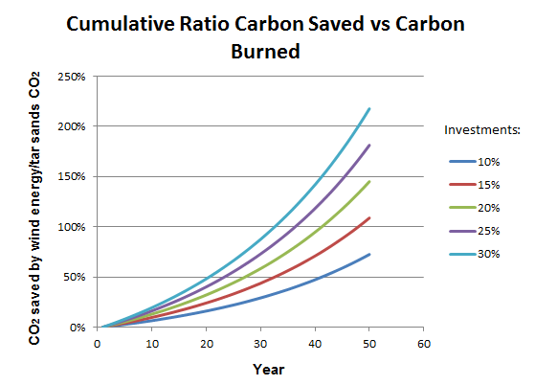

**Figure 3.** Amounts of CO2 offset with different investments in Wind Energy

**Table 2.** Amount of CO2 saved by Wind Turbines

|  |  |
| --- | --- |
| **Description** | **Value** |
| Turbine Peak Power (MW) | 5 |
| Capacity factor | 40% |
| Land area per turbine (km2) | 1 |
| Percent land area for wind turbines | 50 % |
| Area of wind farm (km2) | 70,100 |
| (Square Miles) | 27,383 |
| Square size (miles x miles) | 165 |
| Something | Something |
| Number of turbines to be built for land area | 70,100 |
| Average Power generated (GW) | 198 |
| Average annual energy produced (TWHr) | 1,734 |
| **CO2 saved by wind turbines (megatonnes/year)** | **1,684** |

**Results from Investing in Wind Energy**

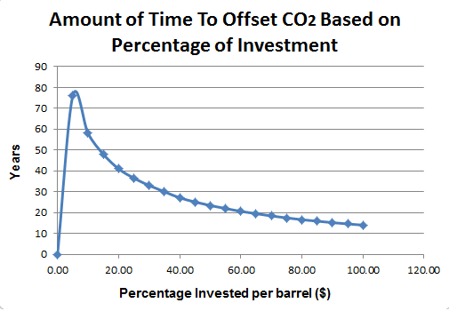

**Figure 4.** CO2 offset timelines with different investments in Wind Energy

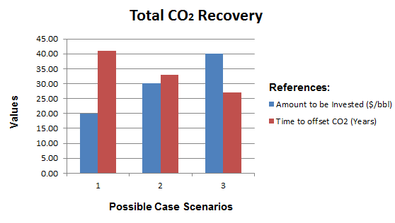

**Figure 5.** Best case scenarios to offset CO2 with Wind Energy. Scenario 1: Investment of 20% per bbl. Scenario 2: Investment of 30% per bbl, Scenario 3: Investment of 40% per bbl

**Estimated Results For Wind:**

* 15% Investment will produce an offset of CO2 in 48 years
* **20% Investment will produce an offset of CO2 in 41 years**
* 25% Investment will produce an offset of CO2 in 36.5 years
* 30 % Investment will produce an offset of CO2 in 33 years
* 40 % Investment will produce an offset of CO2 in 27 years

**Assumptions**

* **Wind Turbine Peak Power**
  + The choice of 5 MW/km2 is conservative and forthcoming are 7 MW turbines, although they will require larger spacing. Even 10 MW turbines are under consideration for production.
* **Wind Turbine Capacity Factor**
  + NRELs median capacity factor to be 40% for onshore wind turbines
  + With higher hub heights, up to 140m, wind turbine net capacity factor could rise to 50%
* **Land area per turbine**
  + Land area assumed to cover 1 km2 per turbine, many wind farms actually would place up to two turbines in this area.
* **Percent land area for wind turbines**
  + Assumption to cover 50% of the total Alberta oil sands area
* **Revenue generated** 
  + All revenue generated gets reinvested into wind equipment purchasing. This also includes the maintenance of wind turbines

## 3.2 EROI from Investing in Solar Energy

Wind power can produce energy 24/7 as long as the wind blows. For some regions solar, even as far North as the oil sands, might be an option.

If one were to invest 20% of the portion of the sales ($20/bbl for this scenario) and put one 1600mm x 1020mm PV solar panel in an area of 1MW per 8.3 acres [11] in a total of 14,020 kilometer square land area (15 % of the Alberta Oil sands area), then this approach would offset the CO2 created by mining and using the oil sands oil in approximately 80 years while producers could once again benefit from the use of electric power for mining and production of the oil sands. Figure 6 shows different scenarios for different percentage of investment.

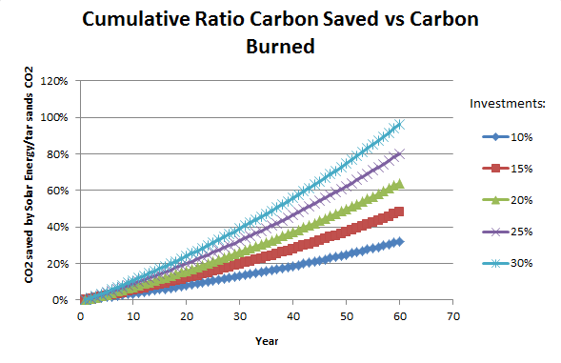

**Figure 6.** Amounts of CO2 offset with different investments in Solar Energy

**Table 4.** Amount of CO2 saved by not burning coal to produce energy by Solar

|  |  |
| --- | --- |
| Description | Value |
| Peak power of solar cell (MW) | 0.00130 |
| Percent land area assumed covered by PV fields | 15% |
| Area of PV farm (km2) | 14,020 |
| (Square miles) | 5,477 |
| Square size (miles x miles) | 74 |
| Land area per solar panel (km2) | 0.00163 |
| Number of solar panels to be built for land area | 8,590,686 |
| Density of coverage on land designated for PV fields | 30% |
| Area of PV cells (m2) | 4,206,000,000 |
| PV cell efficiency | 15% |
| Average 24/7 solar insolation April (Wh/m2/day) |  |
| June | 6,250 |
| January | 1,389 |
| Average power (assumes 24/7 operation made possible with storage technology) (GW) |  |
| June | 164 |
| January | 37 |
| Average | 100.405 |
| **CO2 saved by not burning coal to produce energy generated by solar (magatonnes/year)** | **854** |

**Results from Investing in Solar Energy**

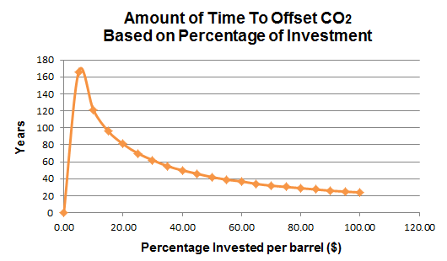

**Figure 7.** CO2 offset timelines with different investments in Solar Energy

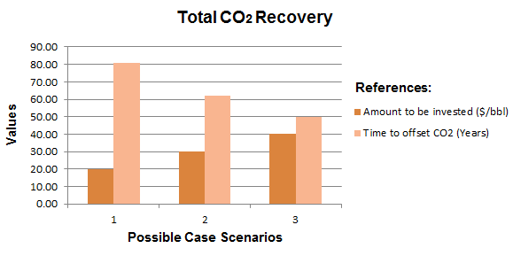

**Figure 8.** Case scenarios to offset CO2 with Solar Energy. Scenario 1: Investment of 20% per bbl. Scenario 2: Investment of 30% per bbl, Scenario 3: Investment of 40% per bbl

**Estimated Results For Solar:**

* 15% Investment will produce an offset of CO2 in 96 years
* **20% Investment will produce an offset of CO2 in 81 years**
* 25% Investment will produce an offset of CO2 in 70 years
* 30 % Investment will produce an offset of CO2 in 62 years
* 40 % Investment will produce an offset of CO2 in 50 years

**Assumptions**

* **Peak Power of PV cell**
  + Assumption to be 1.3kW solar photovoltaic system. In Alberta, a cell will typically produce between 1000 and 1400 kWh per year [10]
  + Most solar panels come at roughly two sizes. We assume that this solar panel is 1600mm x 1020mm. [11]
* **Percent land covered by PV fields**
  + Assumption to cover 15% of land area
* **Density of coverage on land designated for PV fields**
  + Assumption to cover 30% of land area
* **Efficiency of PV fields**
  + For this analysis, OPV efficiency was estimated to be only 15%.
  + Dave DeGraaff, SunPower’s general manager, estimates PV cells efficiency to achieve 23% by 2015 [20]
* **Cost of installation of PV fields**
  + Estimated to be $4/W
* **Revenue generated**
  + All revenue generated gets reinvested into purchasing solar equipment. This includes the maintenance of solar panels

## 3.3 CO2 offset Calculation

The CO2 offset percentage is obtained with the following formula:

$${Carbon}_{offset}= \frac{Amount of CRCS (Cumulative Ratio Carbon Saved)}{Amount of CB (Carbon Burned)}$$

To compute the amount of CRCS (Cumulative Ration Carbon Saved):

$${CRCS}_{t+1} ={CRCS}_{t }+ \frac{{\# installed wind turbines}_{t}}{\# total turbines to be built for land area}× α$$

Where:

* $α= {CO}_{2} saved by not burning coal to produce energy generated by wind$ from Table 2

$t=time (years)$

To compute the amount of CB (Carbon Burned):

$${CB}_{t+1}= \sum_{i=0}^{t}{{CB}_{t}}$$

Where:

* ${CB}_{t}= Total {CO}_{2} per year from tar sands (megatonnes/year)$ from Table 1

# 4 An Alternative to a Carbon Tax

The percentage to be invested per barrel of oil sand is an alternative to a carbon tax. Instead of paying a tax, this approach allows companies to invest into its own future and prevent forestall a carbon tax. This is a win-win situation for the government, the companies, and everyone else on this planet.

According to Cenovus, the are no tax incentives available that are specific to oil sands production. There may be industry-wide tax breaks, but they are the same for conventional oil production and for bitumen production [21].

 A carbon tax—which, granted, we’re still a long way from—would add about $2 to a barrel of Western Canadian heavy crude. And that’s a conservative estimate, says Lewis, who mentions the possibility of President Obama using a carbon tax as a concession to his base if he were to approve the Keystone XL [26].

# 5 Market Expansion and Supply Cost Reduction

The biggest challenge in the Alberta oil sand industry is that there not enough pipelines to transport the oil to Western Canada and down to U.S. refiners. Consequently, much of the oil is finding its way out of Alberta on trains and even trucks, which can be [two or three times more expensive](http://www.businessweek.com/articles/2013-06-13/amid-u-dot-s-dot-oil-boom-railroads-are-beating-pipelines-in-crude-transport) than sticking it into a pipeline. Those extra transportation costs push down the price at the well [26]. producers using expensive options such as trucking and railroads to move their crude. The environmental review included are a wide variety of cost estimates for tar sands by rail, with rail shipments to the Gulf Coast costing $15 to $20 a barrel [27].

## 5.1 Selling Electricity Back to the Grid

TODO: Find out why Alberta is bringing electricity from BC? What are they looking into doing with it?

About 41 percent of Alberta’s installed electricity generation capacity is from coal, almost 40 percent from natural gas, and almost 8 percent from wind [25].

## 5.2 Cleaning Water Contamination

The Athabasca River is part of the third largest watershed in the world. Processing one barrel of bitumen requires approximately three barrels of water [8]. The contaminated water is then pumped into giant tailings ponds alongside the shore.

The Province of Alberta is creating man-made lakes to store the contaminated water produced from the process used to turn bitumen into diesel and other fuels. Reservoirs filled with oil sands wastewater are predicted to cover almost 62,000 acres by 2020 [14].

In these contaminated waters we find high levels of “[Polycyclic Aromatic Hydrocarbons](http://en.wikipedia.org/wiki/Polycyclic_aromatic_hydrocarbons)” or PAHs. We want to make something useful with these compounds in the contaminated water. Every time you have an Aromatic Organic Molecule, you have the potential to crank it which means that breaking the hydrogen and making something useful such plastics and pesticides like Mothballs. The excess wind power could be used as part of the cranking process.

There are times that the grid does not want the excess power generated by the turbines, like at night, hence the cranking plants would run at night. So, during the day the plant runs on battery power. At night, it runs on the excess power from turbines that the grid does not want.

.

TODO: Maybe expand the point of possible production of plastics and pesticides. For a barrel of water, how much PAH is in it? How would that cranking process work?

# 6 Conclusion

It is appears to be economical and politically prudent to undertake as soon as possible a project to install 10 wind turbines on reclaimed land and study the project to ascertain true costs, risks, and benefits with respect to ultimately widespread application of this reclamation strategy.

In parallel, it would be good to conduct a detailed business analysis (short and long term return of investment ROI) of the hypotheses presented here, including:

1. The requirement of investing 20% of gross income from oil sands into renewable energy sources as part of land reclamation and to provide electricity for processing the oil sands, and then selling excess electricity back to the grid.
2. The ability of a) above to encourage the US to approve of the Keystone pipeline
3. The time effect cost of releasing a lot more CO2 now in exchange for a long term greater reduction.

# References

[1] Attanasi, Emil D.; Meyer, Richard F. [*"Natural Bitumen and Extra-Heavy Oil*"](http://www.worldenergy.org/documents/ser_2010_report_1.pdf) (PDF). Survey of energy resources (22 ed.). [World Energy Council](http://en.wikipedia.org/wiki/World_Energy_Council). pp. 123–140. 2010.

[2] *About Oil Sands: Facts and Statistics*. Retrieved March 13, 2014, from

http://www.energy.alberta.ca/oilsands/791.asp

[3] http://www.scientificamerican.com/article/oil-sands-and-keystone-xl-pipeline-impact-on-global-warming/

[4] U.S Department of State. *The Final Environmental Impact Statement*

*(FEIS).* January 2014

[5] Prystupa, Mychaylo. *Alberta doctor tells U.S.: Canada is lying about oil*

*sands health effects*. Retrieved Feb 27, 2014, from

https://www.vancouverobserver.com/news/

[6] *Oil Shale/Oil Sands Guide.* Retrieved March 13, 2014, from

http://ostseis.anl.gov/guide/oilsands/index.cfm

[7] R.D White (Robert Douglas), *Global Environmental Harm: Criminal Per-*

*pectives*. Cullompton, Devon; Portland, Or.: Willan Pub. 2010.

[8] Mettler, Peter. *Petropolis: Aerial Perspectives on the Alberta Oil Sands.*

Documentary. 2009.

[9] [*Alberta's Oil Sands: Opportunity, Balance*](http://www.environment.alberta.ca/documents/Oil_Sands_Opportunity_Balance.pdf). Government of Alberta. March 2008. Retrieved March 19, 2014.

[10] *1.41 kW Grid Tie Solar Power System; Edmonton, Alberta.* Retrieved March 23, 2014. http://www.skyfireenergy.com/

[11] *Solar Panel Dimensions*. Retrieved March 19, 2014. http://greenforcesolar.com.au

<http://spectrum.ieee.org/energywise/green-tech/solar/report-counts-up-solar-power-land-use-needs>

[12] Korosec, Kirsten. *97% of American Overestimate Cost of Installing Solar*. Retrieved March 19, 2014. http://www.smartplanet.com/

[13] *Carbon Sequestration Facts.* Retrieved March 19, 2014. http://www.forestecologynetwork.org.

[14] Loon, Jeremy Van. *Land of Oil Lakes.* Bloomberg Businessweek November 2013, Issue 4356, p15-16.

[15] Walsh, Bryan. *North Dakota Derailment Shows Dark Side of America's Oil Boom.* Time.com January 2014, p1-1-1

[16] Walsh, Bryan. *Report Raises No Major Climate Objections to Keystone Pipeline, But the Choice Is Obama's.* Time.com January 2014, p1-1-1

[17] Poisson et al*. A Time Series Analysis of Canadian Gas and Oil*. Nov 2013

[18] Kurek, et al. [*Legacy of a half century of Athabasca oil sands development recorded by lake ecosystems*](http://www.pnas.org/content/early/2013/01/02/1217675110.full.pdf). Proceedings of the National Academy of Sciences of the United States of America (National Academy of Sciences of the United States of America): 1–6. Retrieved 9 January 2013.

[19] Crude Oil Forecast, Markets & Transportation. CAPP. Retrived on April 1, 2014. <http://www.capp.ca/forecast/Pages/default.aspx>

[20] <http://www.forbes.com/sites/peterdetwiler/2013/07/16/as-solar-panel-efficiencies-keep-improving-its-time-to-adopt-some-new-metrics/>

[21] <http://theenergycollective.com/robertrapier/314966/cost-production-and-energy-return-oil-sands>

[22] <http://www.neb.gc.ca/clf-nsi/rnrgynfmtn/nrgyrprt/lsnd/pprtntsndchllngs20152006/qapprtntsndchllngs20152006-eng.html>

[23] <http://oilprice.com/Alternative-Energy/Nuclear-Power/Canada-Considering-Nuclear-Reactors-in-Alberta-Tar-Sands-Fields.html>

[24] Using Molten Salt Nuclear Reactors in the Oil Sands

[25] <http://www.energy.alberta.ca/Electricity/681.asp>

[26] <http://www.businessweek.com/articles/2013-12-03/why-canadas-oil-sands-look-like-a-shaky-investment>

[27] <http://switchboard.nrdc.org/blogs/aswift/a_deeper_dive_states_environme.html>

[28] <http://www.macleans.ca/economy/economicanalysis/rubin-oil-sands-and-the-bitumen-bubble/>